TOURISM GRANTS
The Sumner County Tourism Grants are made possible through funding allocated from the county’s collected Occupancy Tax paid by visitors staying in our community’s hotels, motels and Airbnb/VRBO short-term rentals. These grants are awarded based on funds available, quantity of requests received and grant matrix scoring. Total grant requests may exceed allocated funding budget, and proposed projects may not be funded and/or not fully funded.
Overview
- Eligible events and projects must take place between July 1 of the current year through June 30 of the upcoming year
- Fiscal Year 2025 application deadline is waived due to the transition from our previous system. Applications will be accepted for events and projects running 7/1/24-6/30/25 at any time.
- Fiscal Year 2026 applications must be received between 3/1/25 and 4/30/25. Late applications will not be considered.
- Grants are paid on a reimbursement basis. Grantees must submit invoices and proof of payment to receive reimbursement up to the approved amount. This includes, but is not limited to bank statement, credit card statement, cleared check, etc.; QuickBooks copies or copies of the front of the check does not fulfill this requirement.
- As applicable, grant recipients must have an updated Sumner County Tourism brand logo on related event homepage with click-through link to www.visitsumnertn.com. Logo artwork will be provided by Sumner County Tourism.
- As applicable, grant recipients receiving funds related to an event must submit event details to madie@visitsumnertn.com for inclusion on our website https://visitsumnertn.com/events/

Timeline
- Applications open March 1st end of April (due to SCT by end of day April 30th)
- Submissions reviewed and scored in May and voted upon in June
- Notifications made by June 30th
- Final report and reimbursement request, including proof of purchase documentation, due to SCT within 90 days of occurrence; if items in their entirety are not submitted within that timeframe, they will no longer be eligible for reimbursement and the grant is forfeited
- Reimbursements will be issued by SCT within 30 business days of final report and reimbursement request submission

These grants exist to extend the marketing of local events and attractions to communities outside of Sumner County, as well as to develop and enhance local events to increase visitation and tourism-generated revenue to Sumner County, while leveraging tourism to improve the quality of life for our residents. To learn more about the grants, eligibility and application requirements below, reach out to madie@visitsumnertn.com with any additional questions.

Marketing/Event Grant
Value: Up to $10,000
Eligibility: Sumner County municipality, 501(c)3 or 501(c)6 organizations and qualified licensed Sumner County tourism-related businesses. Qualifying new events or existing events with a qualified enhancement or improvement are eligible for a single year or up to three years of funding.
Requirements:
  - Funds must be used for promotion and advertising outside Sumner County.
  - For recurring event, a Profit & Loss detail for the last occurrence of the event must be included with submission
  - If related to a first-time event, a proposed P&L and list of available funds/sponsorships received is required.
Examples:
  - Design, printing and mailing of direct mail advertising
  - Social media digital advertising
  - Television, radio or print media advertising

Considerations: Multi-year requests will be reviewed based on strength or project and record of submitting organization’s adherence to timelines and reporting requirements.

Sumner County Tourism Grants are awarded based on funds available, quantity of requests received and grant matrix scoring. Total grant requests may exceed allocated funding budget, and proposed projects may not be funded and/or not fully funded.
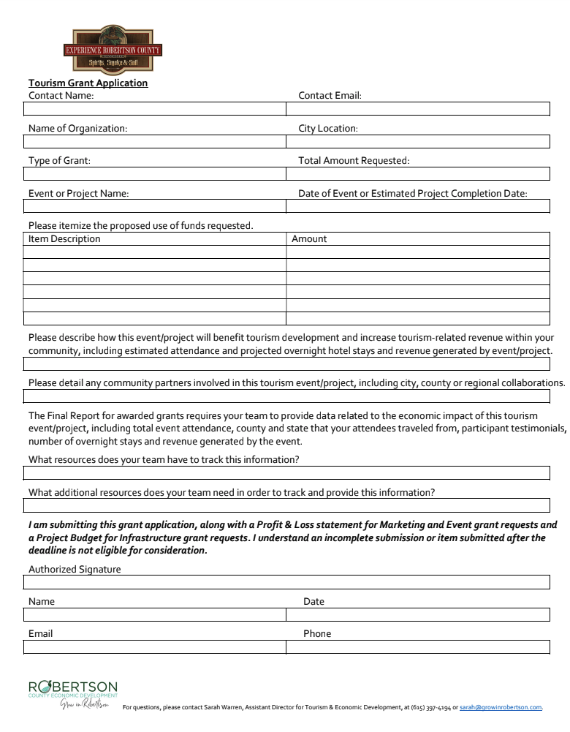

Approved funds are eligible to be reimbursed within 90 days of event or project completion with submission of invoice(s), proof of payment and final report below. Items not submitted in their entirety within that time frame are forfeited for reimbursement.
The most effective reports include the raw zip code/origin location data, as well as overview of what percentage of attendees came from outside of Sumner County with number of states and/or counties represented, any quotes from attendees and/or images from event to paint the picture of the experience.
Reach out to madie@visitsumnertn.com with any questions related to final reporting and/or reimbursement documentation submission.
Step 1: Prepare Your Documentation
There are several pieces of documentation that are required in our grant approval process. We recommend you complete the application and create the additional documentation listed below before proceeding to Step 2. We recommend saving these as PDF, DOC or XLS files.
Download and Complete the Application
Reimbursement documentation includes invoices and corresponding proof of payment. This includes, but is not limited to, bank statement, credit card statement, cleared check, etc.; QuickBooks copies or copies of the front of the check does not fulfill this requirement.
Additional information you would like to share (including data tracking, event images, press coverage, etc.)
Step 2: Complete the Form and Submit Documents
Complete the application and submit your documents by email to: madie@visitsumnertn.com to complete the application process. When submitting supporting documentation be sure to include the following information:
Contact Name, Contact Email, Name of Organization, City in Which the Organization/Agency is Located, and Event or Project Name.
You will receive a confirmation email once all documentation has been received.

Criteria | Scale of 0 to 5, with 0 being unacceptable and 5 being most acceptable
 | Missing  0 points | Fair  1-2 points | Good  3-4 points | Excellent  5-6 points | Score
Alignment with SCT grant program goals (developing tourism as an economic driver; increasing tourism-related economic impact; promoting the county’s tourism brand) | Unclear and/or does not align | Vague and/or offers limited alignment | Clearly defined and offers satisfactory alignment | Clearly defined and highly aligns
Tourism impact (economic impact of drawing non-residents to spend taxable dollars in our county on lodging, dining, shopping, etc.) | Unclear or no impact to tourism development or tourism-related revenue | Limited impact to tourism development or tourism-related revenue | Satisfactory impact to tourism development or tourism-related revenue | High impact to tourism development or tourism-related revenue
Budget/P&L is reasonable and detailed | Unclear or not submitted | Vague and/or yields concerns related to sustainability | Clear and reflects satisfactory sustainability | Clear and reflects sustainable growth
Collaboration (involving other city, county or regional partners) | Offers no collaboration within community, county or beyond | Vague and/or limited collaboration | Clear collaboration | Clear collaboration at community and county/regional level
If prior grant recipient, the quality of their application submission, reimbursement request and final reporting | Late or incomplete items | Completed submission, but required support | Completed timely and thorough submissions; required limited support | Completed timely and thorough submissions; required no support
Total Score

